**AIM: ANIMATE A SIMPLE NETWORK USING NETANIM IN NETWORK SIMULATOR.**

**THEORY:**

**SOURCE CODE:**

#include "ns3/core-module.h"

#include "ns3/network-module.h"

#include "ns3/csma-module.h"

#include "ns3/internet-module.h"

#include "ns3/point-to-point-module.h"

#include "ns3/applications-module.h"

#include "ns3/ipv4-global-routing-helper.h"

#include "ns3/netanim-module.h"

#include "ns3/mobility-module.h"

using namespace ns3;

NS_LOG_COMPONENT_DEFINE ("FirstScriptExample");

int main (int argc, char *argv[])

{

CommandLine cmd (__FILE__);

cmd.Parse (argc, argv);

LogComponentEnable ("UdpEchoClientApplication", LOG_LEVEL_INFO);

LogComponentEnable ("UdpEchoServerApplication", LOG_LEVEL_INFO);

NodeContainer nodes;

NodeContainer routers;

nodes.Create (1);

routers.Create(4);

NodeContainer csmaNodes;

csmaNodes.Create (3);

InternetStackHelper stack;

stack.Install (nodes);

stack.Install (routers);

stack.Install (csmaNodes);

//subnet1

PointToPointHelper pointToPoint;

pointToPoint.SetDeviceAttribute ("DataRate", StringValue ("5Mbps"));

pointToPoint.SetChannelAttribute ("Delay", StringValue ("2ms"));

NodeContainer subnet1;

subnet1.Add(nodes.Get(0));

subnet1.Add(routers.Get(0));

NetDeviceContainer Subnet1devices;

Subnet1devices = pointToPoint.Install (subnet1);

Ipv4AddressHelper subnet1address;

subnet1address.SetBase ("10.1.1.0", "255.255.255.0");

Ipv4InterfaceContainer p2pInterfaces1;

p2pInterfaces1 = subnet1address.Assign (Subnet1devices);

//subnet2

NodeContainer subnet2;

subnet2.Add(routers.Get(0));

subnet2.Add(routers.Get(1));

NetDeviceContainer Subnet2devices;

Subnet2devices = pointToPoint.Install (subnet2);

Ipv4AddressHelper subnet2address;

subnet2address.SetBase ("10.1.2.0", "255.255.255.0");

Ipv4InterfaceContainer p2pInterfaces2;

p2pInterfaces2 = subnet2address.Assign (Subnet2devices);

//subnet3

NodeContainer subnet3;

subnet3.Add(routers.Get(1));

subnet3.Add(routers.Get(2));

NetDeviceContainer Subnet3devices;

Subnet3devices = pointToPoint.Install (subnet3);

Ipv4AddressHelper subnet3address;

subnet3address.SetBase ("10.1.3.0", "255.255.255.0");

Ipv4InterfaceContainer p2pInterfaces3;

p2pInterfaces3 = subnet3address.Assign (Subnet3devices);

//subnet4

NodeContainer subnet4;

subnet4.Add(routers.Get(1));

subnet4.Add(routers.Get(3));

NetDeviceContainer Subnet4devices;

Subnet4devices = pointToPoint.Install (subnet4);

Ipv4AddressHelper subnet4address;

subnet4address.SetBase ("10.1.4.0", "255.255.255.0");

Ipv4InterfaceContainer p2pInterfaces4;

p2pInterfaces4 = subnet4address.Assign (Subnet4devices);

//subnet5

CsmaHelper csma;

csma.SetChannelAttribute ("DataRate", StringValue ("100Mbps"));

csma.SetChannelAttribute ("Delay", TimeValue (NanoSeconds (6560)));

NodeContainer subnet5;

subnet5.Add(csmaNodes.Get(0));

subnet5.Add(csmaNodes.Get(1));

subnet5.Add(csmaNodes.Get(2));

subnet5.Add(routers.Get(2));

NetDeviceContainer csmaDevices;

csmaDevices = csma.Install (subnet5);

Ipv4AddressHelper subnet5address;

subnet5address.SetBase ("10.1.5.0", "255.255.255.0");

Ipv4InterfaceContainer p2pInterfaces5;

p2pInterfaces5 = subnet5address.Assign (csmaDevices);

UdpEchoServerHelper echoServer (9);

ApplicationContainer serverApps = echoServer.Install (csmaNodes.Get (0));

serverApps.Start (Seconds (1.0));

serverApps.Stop (Seconds (10.0));

UdpEchoClientHelper echoClient (p2pInterfaces5.GetAddress (0), 9);

echoClient.SetAttribute ("MaxPackets", UintegerValue (1));

echoClient.SetAttribute ("Interval", TimeValue (Seconds (1.0)));

echoClient.SetAttribute ("PacketSize", UintegerValue (1024));

ApplicationContainer clientApps = echoClient.Install (nodes.Get (0));

clientApps.Start (Seconds (2.0));

clientApps.Stop (Seconds (10.0));

Ipv4GlobalRoutingHelper::PopulateRoutingTables();

Simulator::Run ();

Simulator::Destroy ();

return 0;

}

**OUTPUT:**

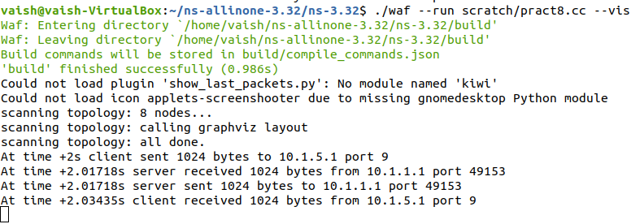

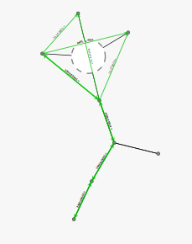

NetAnim:

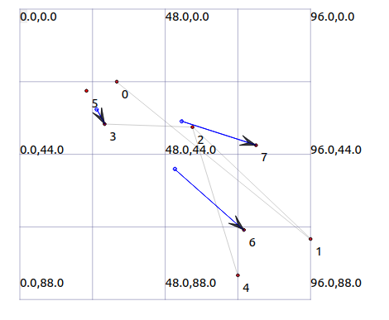

WireShark :



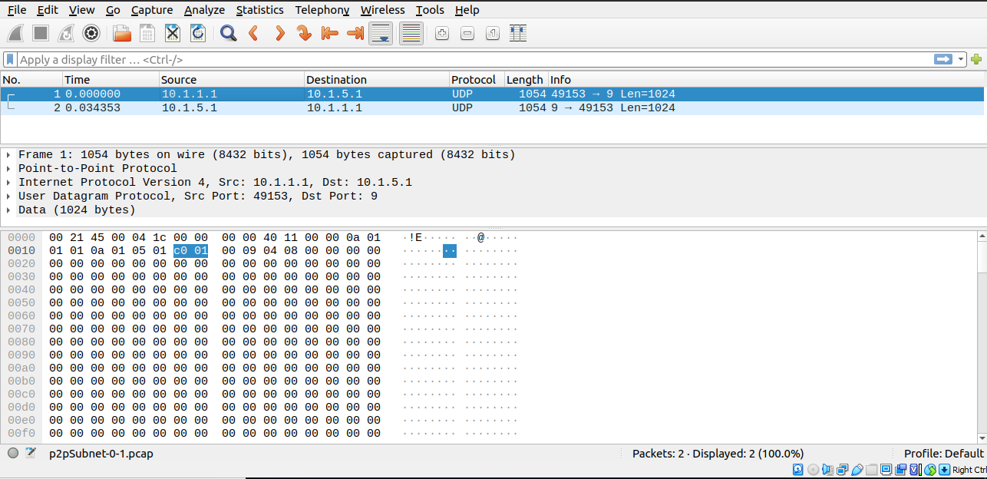

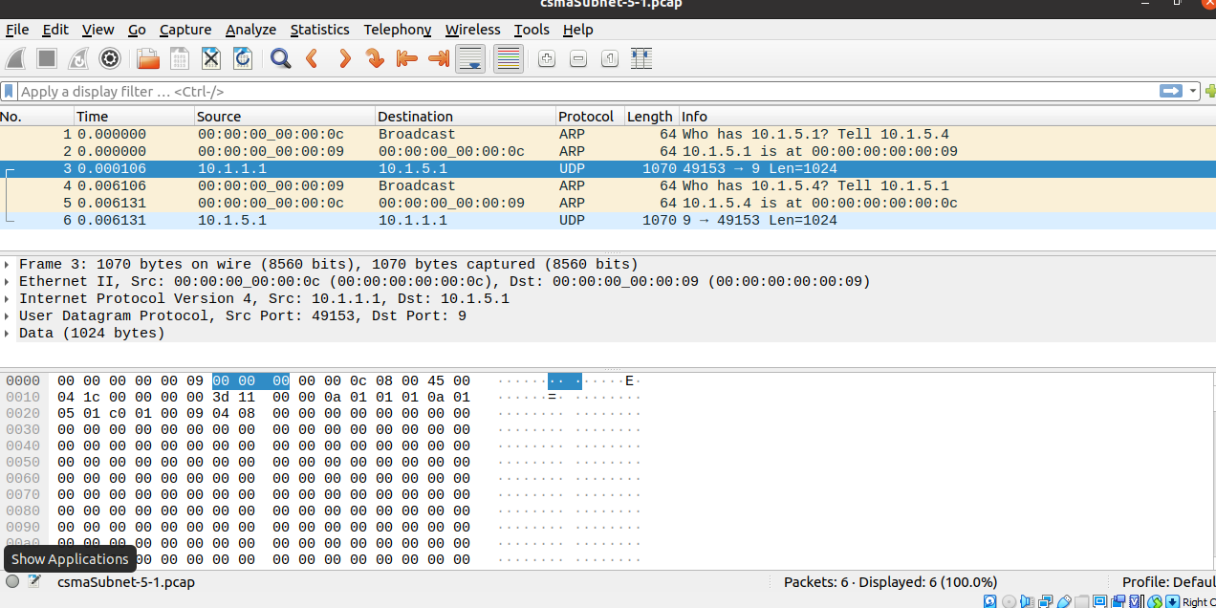

**CONCLUSION:**

From this practical, I have learned how to implement a simple network using NetAnim in Network Simulator executed successfully.